Marketing Materials for NGBS Green Certified Projects
Below are materials that can be used by Home Innovation Research Labs’s green certification partners* to help educate consumers about the ICC 700 National Green Building Standard (NGBS), Home Innovation Labs certification program, and the benefits of Green Certified homes and land developments. Most of the materials are available to download directly from this site; certification marks are for example only – those who are eligible to use the marks receive them directly from Home Innovation Labs. If you believe you are eligible to use a particular mark and have not received it, please contact us.

Logos/Marks
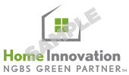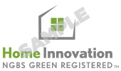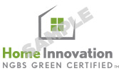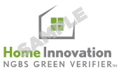

Signage
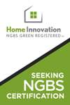 |  | Multifamily Vertical Construction Site Sign  (finish size = 20’x30’) - high-res, print ready PDF file; should be suitable for a professional printer
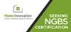 |  | Large-Scale Horizontal Construction Site Sign  (finish size = 12’x6’) - high-res, print ready PDF file; should be suitable for a professional printer
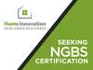 |  | Single-Family Home Yard Sign  (finish size = 24”x18”) - high-res, print ready PDF file; should be suitable for a professional printer
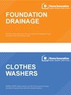 |  | Silent Salesperson  These signs are intended for use within an NGBS Green Certified home (single-family detached or apartment within a certified multifamily building) as a way to highlight green practices that are incorporated into that particular project; can be printed on an office printer or by a professional and laminated or mounted on foam core for display in model homes/units or within a sales/leasing center where these particular green practices are on display.
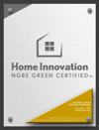 |  | Certification Plaque Ordering Portal  In addition to the certificate you receive from Home Innovation Research Labs to tout the NGBS Green Certified status of your single-family home or multifamily building, you can also order custom engraved plaques through this approved vendor.

Print Collateral
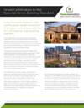 |  | NGBS Certification Overview  (8.5”x11”, two-sided) can be used to educate multiple audiences including government officials
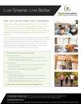 |  | B2C NGBS Green Living Flyer  (8.5”x11”, one-sided) best suited for distribution by certification program partners to home-buying or -renting consumers
* The Home Innovation Research Labs authorizes the use of these materials only by those individuals participating in Home Innovation Research Labs National Green Building Certification and solely for the purposes of such individuals' participation therein. These documents are protected by U.S. copyright law.

